**Scenario 5: Module Development & Deployment for Developer**

Mission :

Identify a missing feature or improvement opportunity through personal use or community discussion.

Create a new module using the Luxoria.Modules, Luxoria.GModules & Luxoria.SDK.

Use CLI tool (buildsystem.py) to build the module locally on the developper'sworkstation.

Upload the module to the Luxoria Marketplace using the API or developer portal.

Provide metadata (version, changelog, dependencies).

Participate in GitHub discussions and propose changes or fixes via pull requests.

Join the official Discord for community interaction and feedback loops.

Update the module based on feedback and release a patch version.

Expected Result :

Developer successfully builds a module using official Template, Luxoria Standard Modules, SDK and CLI tool (LuxCLI).

Marketplace accepts the module upload with correct metadata.

Community interaction channels (GitHub, Discord) support collaboration and feedback

Bug fixes and feature updates are released incrementally and traceably

Module functions reliably within the Luxoria ecosystem, following modular design guidelines.

1. Module Creation

The module which will be created, will be called “LuxImport3”, it will be based on the actual version of LuxImport.

1.1 Fork <https://github.com/LuxoriaSoft/marketplace/> repository

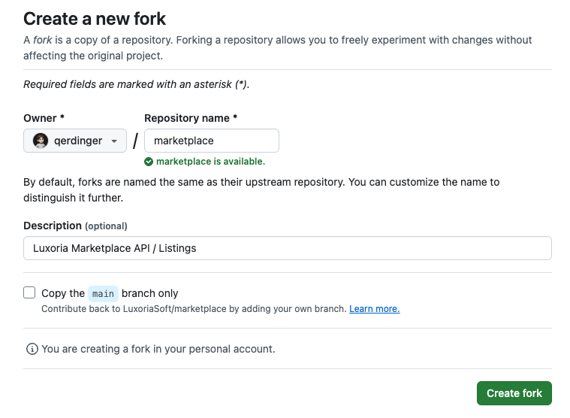

* 1. Clone the forked repository

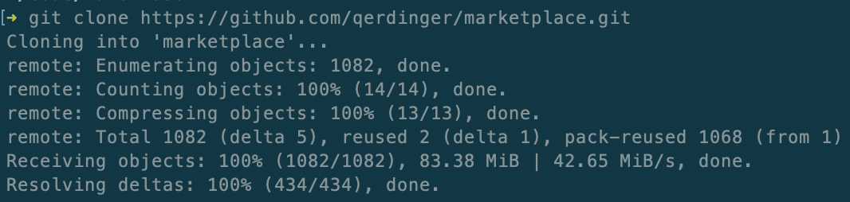

* 1. Select the targeted version of Luxoria



* 1. Create LuxImport3

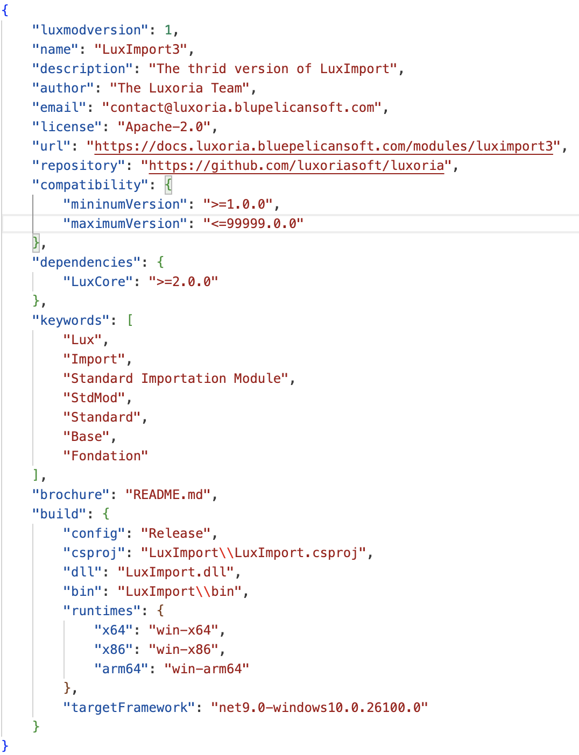

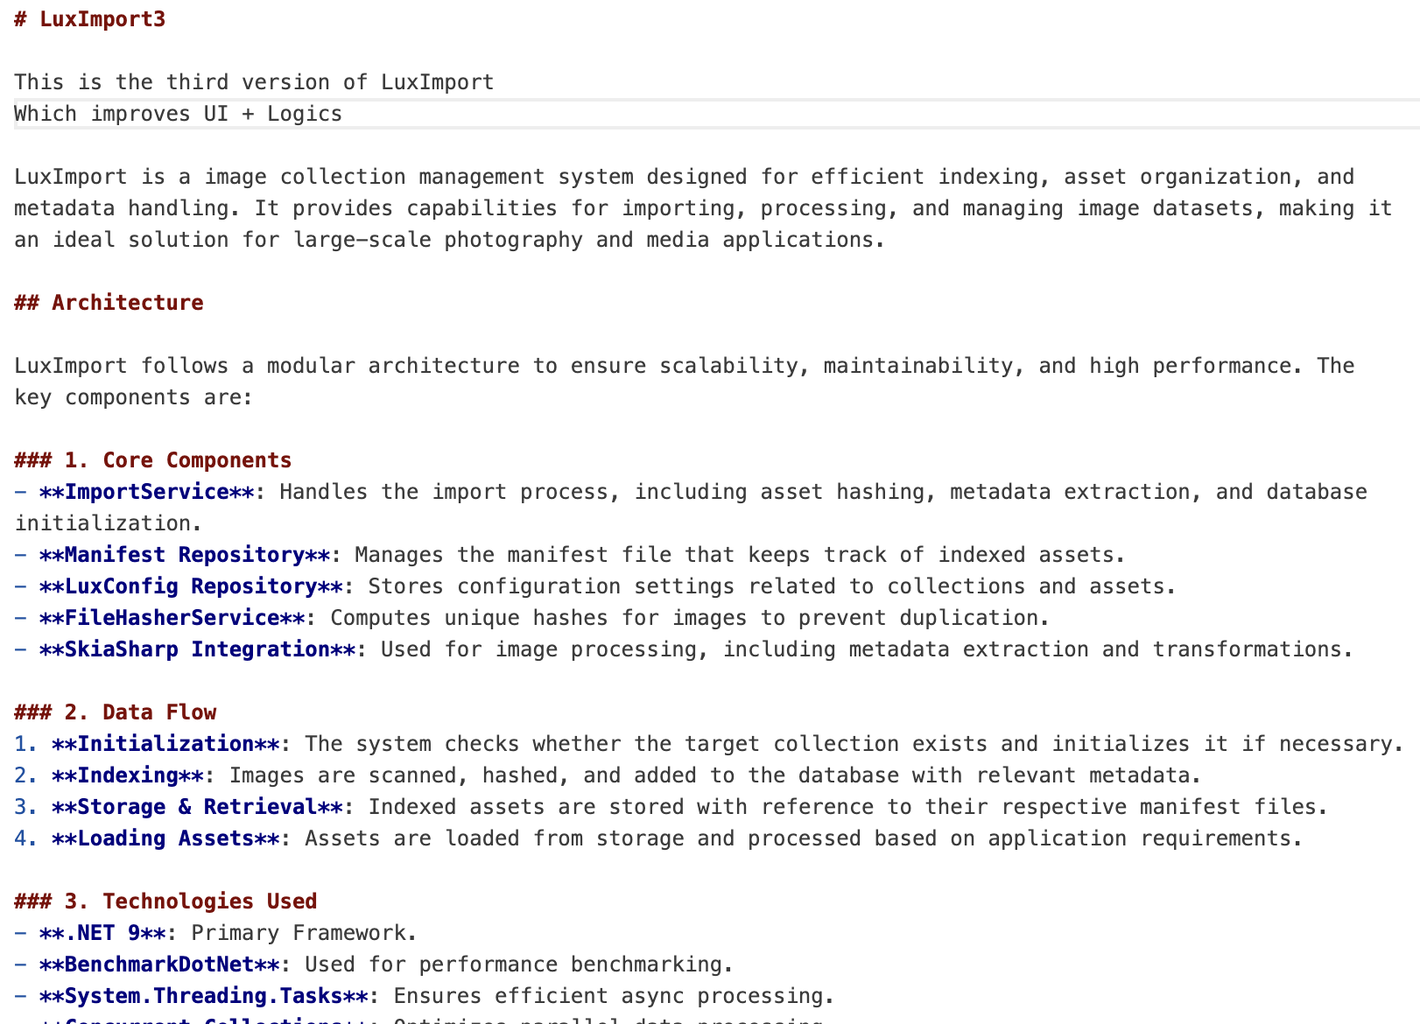

* 1. Commit + Push LuxImport3

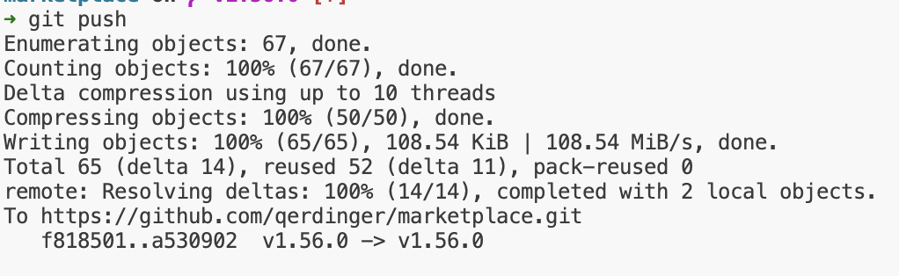

2 Create a pull request to Marketplace

“To integrate LuxImport3 to marketplace, we need to create a pull request that target the targeted version such as LuxoriaSoft:v1.56.0”

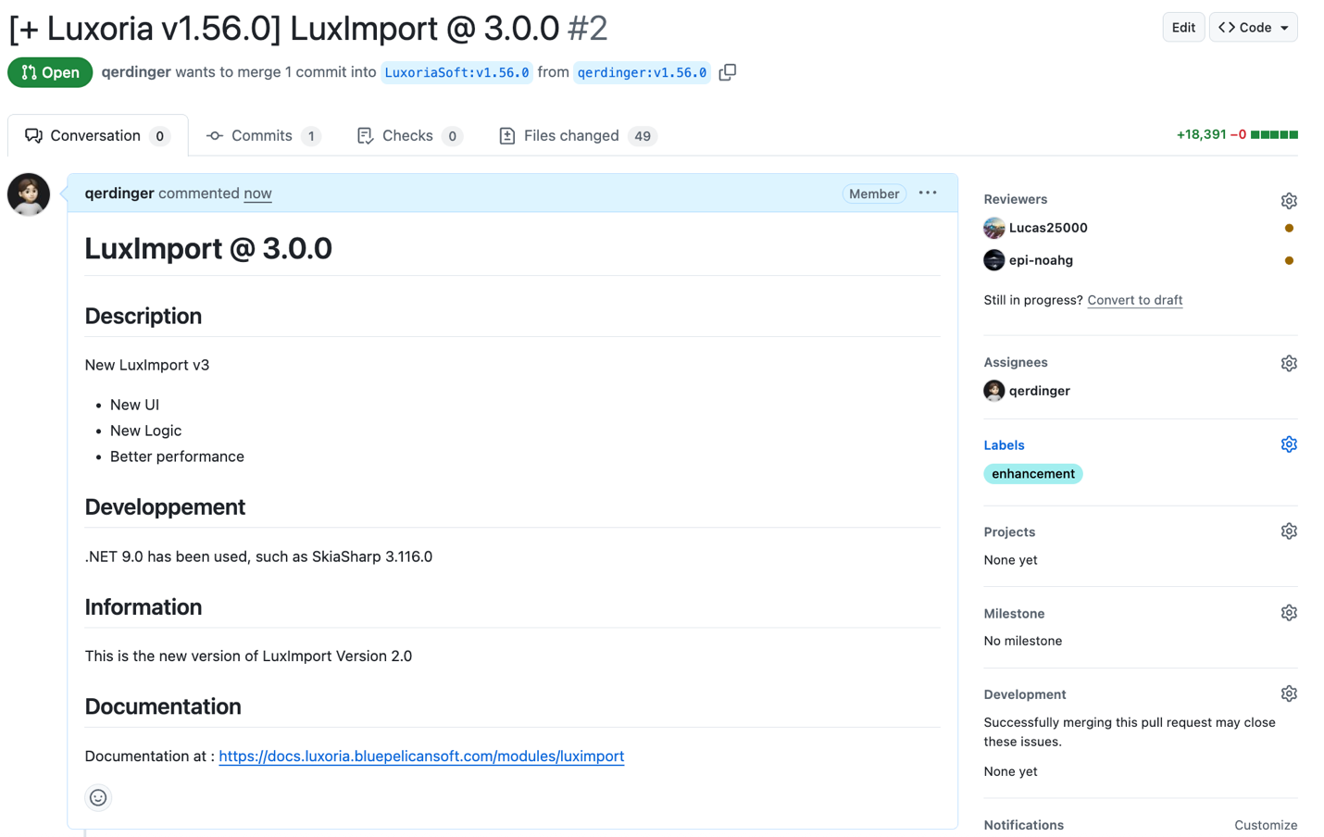

2.1 Wait until the PR has been reviewed & accepted

“A reviewer/administrator has reviewed the PR and accepted it”

Check it out at: <https://github.com/LuxoriaSoft/marketplace/pull/2>

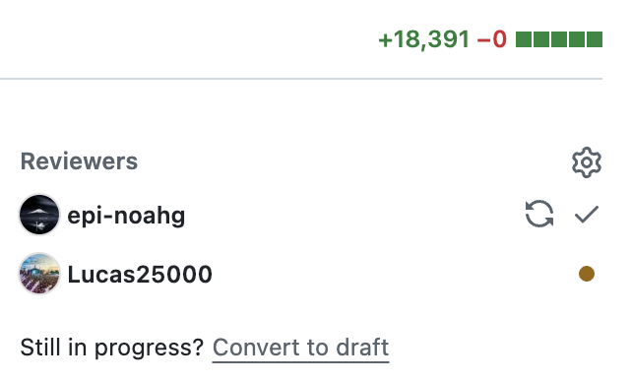

2.2 The PR has been merged

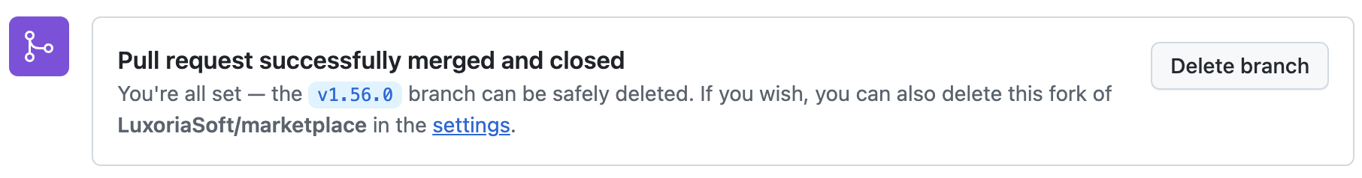

The module will be soon available on the Marketplace (Estimated: 5-10 minutes)

2.2 Keep posted/updated the community on “Luxoria Community”



2.3 Be the first to install the surprisingly new LuxImport3

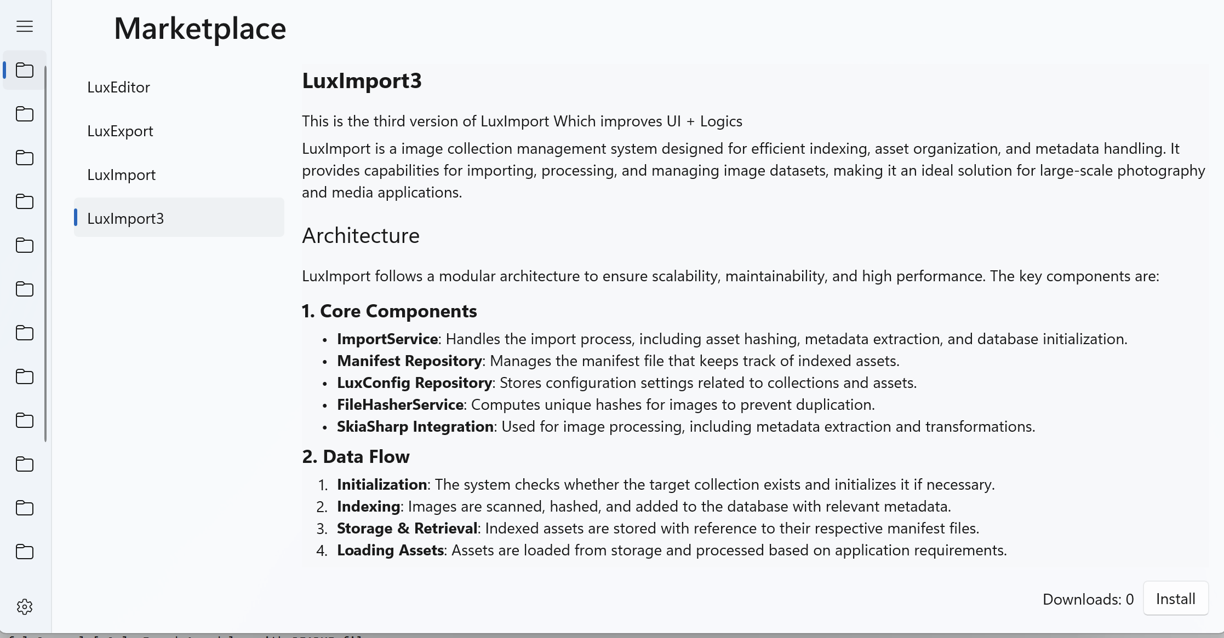

3 Chat with “Luxoria Community”

